**What is Automation System?**

Automation System is defined as the use of control systems and information technologies to reduce the need for human work in production of good and services. The author joined the Project Management Institute Automation Systems Community of Practice.

Although the discipline "Automation System" has been established for long, mostly as a topic in industrial engineering, there are not many specialized, referential or academic association between Project Management and Automation System. (Wikipedia - automation systems, 2011)

Also, automation system has been mostly perceived as a sub-branch of industrial engineering, which is a branch of engineering dealing with the optimization of complex processes or systems.

Industrial engineering is concerned with the development, improvement, implementation and evaluation of integrated systems of people, money, knowledge, information, equipment, energy, materials, analysis and synthesis, as well as the mathematical, physical and social sciences together with the principles and methods of engineering design to specify, predict, and evaluate the results to be obtained from such systems or processes.

Depending on the sub-specialities involved, industrial engineering may also be known as operations management, management science, operations research, systems engineering, or manufacturing engineering In health care, industrial engineers are more commonly known as health management engineers or health systems engineers. ( Wikipedia - industrial engineering, 2011)

## Problem Definitions and Statement

From the literatures, automation systems can be anywhere in agricultural commercial or industrial sectors. However, the main theme "how to automate correctly or better", itself becomes a vertical discipline alone. And this individual discipline itself may need skills, technologies, and knowledge's from many other area(s).

http://www.projectperfect.com.au/images/miscellaneous/dividing_line.gif

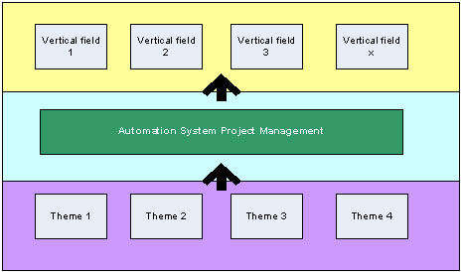

**Conceptual Mapping Framework of the Automation Systems Project Management**

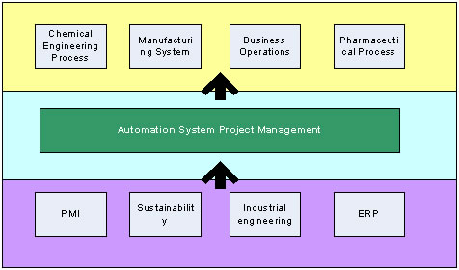

**Example Mapping of the Automation Systems Project Management**

http://www.projectperfect.com.au/images/miscellaneous/dividing_line.gif

Since the idea of automation system project management is relatively new and vague, we need to first carefully clarify our problem statement that is similar to a demarcation. For example, imagine yourself as a project management, how are you going to manage your automation projects in order to achieve results? What do you want to achieve at the end of the day? How can we use "projects" to handle those challenges?

In general what are the common challenges, missions and visions, in automation systems across different industries, that operation management face and feel painful everyday? Are those challenges specifically happening in automation systems only? Can we use existing PMI knowledge to resolve those challenges? How can we extend the existing PMI knowledge to cover managing those challenges?

Another point is, according to PMI, a project is a temporary endeavour, having a defined beginning and end (PMBOK, 2009), while automation systems is business as usual (BAU or operations), which are repetitive, permanent or semi-permanent functional work to produce products or services. We have to identify project management natured tasks or programs that can add value or positive long-term change of the automation systems operations. Such activities can be related to hands-on system or engineering implementation and changes, processes/architecture/ practices changes, or management strategies changes.

We need to clarify what PM plays a role in each kind of activities. For example, a PM is not going implement a robotic arm somewhere in the manufacturing process line, but the PM need to know how to create and manage a project so that experts can perform the implementation. We are not going to document how to perform querying analysis, system optimisation etc, although this can be root cause of many automation systems common problems. We focus on methods or ideas that PM can contribute to the success of the automation system operations.

http://www.projectperfect.com.au/images/miscellaneous/dividing_line.gif

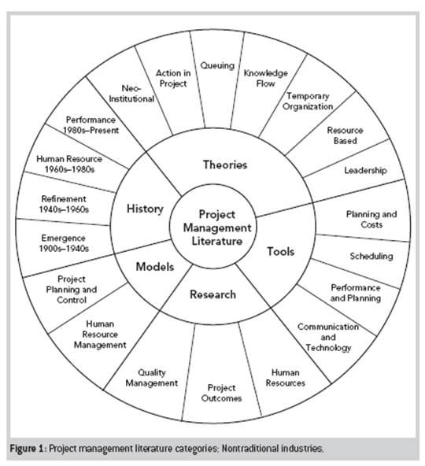

## Abstract

[[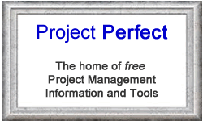](http://www.projectperfect.com.au/project-administrator-software.php)](http://www.projectperfect.com.au/project-administrator-software.php)This paper tries to investigate project management knowledge expansion to a vertical industry - automation systems. First the literature carefully limits the scope of automation systems. It then gathers themes from literature review, map themes between vertical automation systems, PMI common themes and other technical / managerial disciplinary themes. The managerial and technical specific requirements are gathered, understood, and solution themes are proposed for each requirement.

At the end, the literature concludes an integrated management framework is preferable to support automation systems project management. PMO, program and operation management should also get involved so that the whole automation systems project management movement can get enough support within the enterprise.

This is Part 1 of the white paper.